Layers of online reading, research and multimodal synthesis practices while Making: A descriptive study of three fifth-grade students

Michelle Schira Hagerman
Megan Cotnam-Kappel
Julie-Anne Turner
University of Ottawa

and

Janette M. Hughes
University of Ontario Institute of Technology

A paper presented at a Technology in Teacher Education SIG paper presentation session at the Annual Meeting of the Canadian Society for Studies in Education (Vancouver, Canada)
June 5, 2019

DRAFT

Please direct inquiries to Michelle Schira Hagerman mhagerma@uottawa.ca
Faculty of Education, 338 Lamoureux Hall
University of Ottawa
145 Jean-Jacques Lussier Private
Ottawa, ON K1N 6N5
Canada

Abstract
This study describes the layered literacies practices of three bilingual fifth-grade students attending a French-language school in an urban community in Canada as they searched for ideas online, constructed a musical instrument out of recycled materials, and then synthesized their Maker process in a multimodal how-to tutorial using Google slides. Framed by theories of New Literacies, embodiment, and dynamic systems, we used video, captured from the students’ perspectives and researchers’ perspective to document moments of meaning making. Findings offer insights into how students made meaning through each phase of this project, while also challenging assumptions about the role of digital activites such as online search and multimodal composition in relation to the physical, sensory, design-driven practices in which the children engaged.

Keywords: literacies practices, Making, digital composition, online information search, integrated maker pedagogies

Introduction

In the face of overwhelmingly complex globally networked information landscapes, we assert that literacies learning in school must empower students to develop epistemic beliefs that position them as evaluators and as agentive constructors of knowledge so that over time, they might come to view knowledge – including information, in any form, that is shared by friends on the Internet -- as contingent, constructed, and fundamentally crafted to reflect human interests (Barzilai & Zohar, 2012; Barzilai & Strømsø, 2018; Hartman, Hagerman & Leu, 2018).
Learning activities that scaffold evaluativist dispositions and use of critical reading strategies seem to prepare children for the complexities of web-based reading and research, including the integration of information from multiple information sources (Barzilai & Ka’adan, 2017). Recent scholarship suggests that effective methods for teaching students to synthesize complex meanings from multiple, divergent, multimodal information sources include direct instruction of synthesis strategies, discussion, modelling synthesis practices for students, using graphic organizers, and practicing synthesis skills across a range of tasks and for multiple purposes (Barzilai, Zohar & Mor-Hagani, 2018). On balance, these interventions are teacher-centred, or position students as novices who work to acquire particular skills through instructional interventions that have been carefully designed and controlled (e.g., Cameron, Van Meter & Long, 2017; Cerdán & Vidal-Abarca, 2008; Hagerman, 2017a). The Internet, though, is dynamic, difficult to navigate (Coiro & Dobler, 2007) and infinitely complex (Hartman & Morsink, 2010).
To prepare children for the complexities of meaning making in diverse, dynamic, networked information systems, we assert that literacies instruction should embrace rather than control complexity. To develop and refine cross-cutting literacies teaching methods that allow children to practice critical, evaluativist stances, we need more research situated in activities that encourage children to set and revise their own priorities, to seek out information that serves their purposes, and requires them to leverage a range of digital, multimodal, and print-based literacies practices to communicate their understandings (Hughes, Morrison, Mamolo, Laffier & de Castell, 2018).
Maker Literacies
One instructional approach that may empower learners with a deep sense of agency as they construct meanings, and communicate solutions to complex problems is Making (Clapp, Ross, O. Ryan & Tishman, 2017; Halverson & Sheridan, 2014; Martin, 2015; Rowsell & Shillitoe, 2019; Vossoughi, Hooper & Escudé, 2016; Woodard, 2019). Described by Wohlwend, Peppler, Keune & Thompson (2017) as “a range of activities that blend design and technology, including textile crafts, robotics, electronics, digital fabrication, mechanical repair or creation, tinkering with everyday appliances, digital storytelling, arts and crafts—in short, fabricating with new technologies to create almost anything” (p. 445), making can be used in school to activate disciplinary and digital literacies learning practices (Hagerman, 2017b; Wohlwend, Scott, Deliman, Li & Kargin, 2018; Tan, Keune & Peppler, 2017; Woodard, 2019). Importantly, Maker literacies have been theorized as situated, and as culturally framed ways of reading, writing and making meaning with and from texts in all of their forms (Barton & Hamilton, 2000; Lankshear & Knobel, 2008; Haddix & Sealey-Ruiz, 2012; Scribner & Cole, 1981).
In a Makerspace, situated in a school, we assume that any meaning-making practices used (and observed) will be inextricable from context, enacted and embodied in ways informed by language, culture, systems and structures of power. It is not yet understood, however, what literacies practices are enacted when young makers read for information on the Internet in service of their own Making processes, create a digital or physical product, and then compose multimodal texts in which they synthesize evidence of their own learning. For urban, bilingual and multilingual Maker youth attending Canadian schools, we have very little data. And yet, these types of integrated Maker-oriented activities that mash-up elements of personal online inquiry (Coiro, Castek & Quinn, 2016) with digital/material making (e.g., Kafai, Fields & Searle, 2014; Wargo, 2018) and digital composition (e.g., Dalton, 2012; Smith, 2014) seem to have found a footing in Canadian K-12 classrooms as teachers look for innovative and interdisciplinary ways to address curriculum expectations in ways that also support the practices of “deep learning” (Fullan, Quinn & McEachen, 2018): collaboration, critical thinking, creativity, communication, citizenship and character (cf. Fullan & Scott, 2014). In Ontario, these practices are assessed and reported on in the “Learning Skills” section of the provincial report card (Hughes et al., 2018).
As Woodard (2019) aptly notes, educators and researchers have begun to recognize important similarities among the processes inherent to writing, multimodal composing and making (p. 2). Melo (2016), for example, asserts that writing is making and making is writing. In a composition classroom, Melo, suggests that her adult students “discover (invention), tinker with new ideas (research), collaborate with others on their ideas (peer revision), and fail through an iterative process (revision).” Making, which is often collaborative, involves the assemblage (Wohlwend et al., 2018) of physical and/or digital materials as a representation of meaning and writers, as Melo notes, pull together “semiotic resources to say something; to make an argument” (para. 11). Fundamentally, there may be common processes of bricolage and assemblage at the core of these productive, embodied activities (e.g., Barsalou, 2010; Glenberg, 2010) which make us wonder wonder whether Maker activities create conditions through which young students might begin to become critical, agentive, and epistemically evaluativist bricoleurs digital and physical materials.
To answer this question, we need more research, situated in an expanded set of authentic contexts of schooling, that describes and indeed interprets literacies practices in the making (J. Wargo, A. Stornaiuolo & M.S. Hagerman, personal communication, February 27, 2019). Before we can understand the full potential of Making and Maker pedagogies for developing epistemically critical and agentive learners, we first need to conceptualise Making with teachers and explore the literacies practices that students use.
The particular context for our study was therefore chosen carefully. We chose to collaborate with a French-language school in a majority English-speaking setting: Ontario, Canada. As such, student and teacher participants in this study live in a linguistic minority setting in Canada where, as evidence suggests, digital use, and digital skills divides are likely to be more profound (Chaput & Champagne, 2012, Statistics Canada, 2013). Within this linguistic context, and in consultation with the participating school board’s Director of Education, our team chose a school in an urban, low income setting. In our discussions with members of the school’s staff, we learned that the school’s standardized math and literacy test scores are among the lowest in the province, there is a high student turnover rate and that most students come from multilingual homes where neither French nor English are the first language. During our first meeting, the school’s principal also shared that most students must go straight home to their family apartments after school as local parks aren’t safe. During this very same meeting, we also discovered that teachers at this school were dedicated, motivated and looking forward to leveraging technology and Maker pedagogies to create meaningful learning opportunities for their students. Aligning ourselves with research that documents the democratizing power of critical, multimodal projects that open spaces for diverse, marginalized youth (e.g., Cotnam-Kappel, 2014; Honeyford, 2014; Smith, 2014; Stewart et al., 2008), we set out to build knowledge with students and teachers in this school so that we could begin to understand the potential of Making for the broader educational context of our post-truth era.
Theoretical Frameworks
We leverage an integrated set of theoretical assumptions to inform our conceptions and analyses of literacies practices. First, we leverage the core assumptions advanced by the Dual Level Theory of New Literacies (Leu, Kinzer, Coiro, Castek & Henry, 2013; Hartman, Hagerman & Leu, 2018). In particular, we view meaning making online as critical, culturally situated, multimodal, dynamic and complex. We expect that meanings are made in relation to texts, contexts, tasks, reader/writer purposes, and technologies. Further, this theory asserts that lower-level new literacies skills, including the ability to locate, evaluate, synthesize and communicate understandings are central to meaning making processes during online inquiry, and that these skills may vary as a function of family income, access to technologies, and experiences online (Leu et al., 2015). The role of the teacher as guide is also viewed as fundamental.
Current conceptions of Maker literacies (Wohlwend, Scott, Yi, Deliman & Kargin, 2018; Rowsell & Shillitoe, 2019; Wargo, 2018; Woodard, 2019) emphasize embodied, sensory, physical-material interactions. In this work, meaning making is framed in digital-physical activity. By leveraging theories of learning and meaning making as embodied (e.g., Glenberg, 2010) we also understand that the practices of making meaning with texts and through the construction of texts will reside, in part, in the objects our participants create, and in their own self-organizing, grounded sensory experiences with the materials they use (Barsalou, 2010).
Dynamic Systems Theories (Smith & Thelen, 2003; Thelen, 2005), which have framed empirical work in reading development (e.g., Ferrer et al., 2007), second language learning (e.g., DeBot, 2008; Larsen-Freeman & Cameron, 2008) and development of executive functions over time (Marcovitch & Zelazo, 2009) help us to conceptualise learners’ literacies practices as emergent, self-organizing and continuously changing. Thelen (2005) uses the metaphor of the stream which, although always moving, also has “whirlpools, eddies, and waterfalls, places where the water is moving rapidly and places where it is still” (p. 259). She notes that like the stream, development also has patterns and that these patterns “arise from the water, and natural parts of the stream and the environment, such as the streambed, the rocks, the flow of the water, the current temperature and the wind. The patterns reflect not just the immediate conditions of the stream, however; they also reflect the history of the whole system” (p. 259). Importantly, in Dynamic Systems, the water (learner) is understood to sculpt the environment as the environment also, in turn, sculpts the water’s (learner’s) path. In the flow of our participants’ meaning-making processes, we looked to identify the places and moments of stillness, of rapid activity; we looked for the whirlpools and the waterfalls as evidence of emergence, and meaning in the making.
Research Questions
The broader goal for our design-based research program in this post-truth era is to understand whether Making and interdisciplinary maker-oriented projects prepare children to become agentive, critical bricoleurs who understand knowledges as constructions, and are able to construct nuanced, integrative understandings of many types of texts. In this first analysis we aim to unpack the layers of children’s meaning making processes through phases of online search, Making and multimodal composition. With a deeper understanding of what fifth-grade children do or can do, we will be able to reconsider our assumptions, and with teachers, rethink next steps. The current study asks:
- What online reading and research strategies does each student use during the planning phase of the Maker project?
- What literacies practices are evident as each student builds a musical instrument from recycled materials?
- What evidence of multimodal synthesis is visible in each student’s digital composition?

Method

Design
The current study represents the first analysis of data from one of two sites included in a four-year, longitudinal research project focused on understanding literacies learning in Makerspaces for children living in Canadian urban, lower-income contexts, over time.
The four-year study in which this study is situated uses a formative and design-based research methodology that emphasizes the collaborative conceptualization of maker-based learning activities and pedagogies among researchers and teachers, and that allows for iterative shifts in intervention based on careful, ongoing analyses of trends (Barab & Squire, 2004; Reinking & Bradley, 2008).
Research Context
Lauréat Public School (all names are pseydonyms) located in an urban community in Eastern Ontario, offers a French-language curriculum to 340 children, 41.6% of whom live in lower-income households (Ontario Ministry of Education, 2018). According to data released by the Education Quality and Accountability Office (2018), 20% of the children attending the school have lived in Canada for fewer than three years; 68.8% report a language other than French as their first language. Academically, the school ranks in the lowest quartile in the province with 22% of scores on math, reading, and writing tests falling below the provincial standard (Cowley & Easton, 2017).
Teacher Participants
Two fifth grade teachers, Anne-Sophie and Jérôme, agreed to support the goals of this study and to participate in this research with their students. During the design phase, both teachers made recommendations to ensure the project aligned with expectations in the music curriculum for Grade 5 : create and perform music for a variety of purposes; reflect, respond and analyze feelings in response to a range of music and musical experiences; explore forms and cultural contexts for music (Ontario Ministry of Education, 2009, p. 114). Only Anne-Sophie, however, taught the students during the prescribed Maker periods because, as the teacher of a split Grade 5-6 class, Jérôme used this Grade 5 Maker time block to instruct his Grade 6 students. After each Maker learning period, Anne-Sophie shared her observations, reflections, and plans for the next day’s activities. As we constructed understandings of students’ Maker processes, we shared selected videos with both teachers who offered their own insights and interpretations of the students’ activities. The teachers also helped us to select focal participants for this analysis by corroborating our interpretation of the students’ academic skills, which we could only infer from a reading comprehension pre-test that we designed and administered.

Student Participants
Although 20 students opted in (with parental permission) to the study at Lauréat, this study focuses on the literacies practices of three students -- two girls (Nalina and Aisha) and one boy (Noah). Our choice to focus on these children was informed by two factors: (a) their diverse academic strengths and interests that, broadly, represent the academic diversity in their class as confirmed by their teachers and indicated by their relative scores on a reading comprehension test administered before they began their maker activities (Max score = 23); and (b) their completion of all phases of the study. Although we first identified three other students for representative inclusion in this preliminary analysis, missing data for each of them at one phase of the project (e.g., no tutorial, no video) resulted in a set of three participants for this analysis.
Table 1
Overview of participant information
Student | Instrument  Created | RC Score  /23 | Total Length of Videos analysed (mins)
Nalina | Tamboumara (drum and maraca) | 12 | 82.12
Aisha | Pan flute | 17 | 56.22
Noah | Tangour (guitar and drum) | 6 | 62.12

The Task
After reading about musical instruments, and sharing what they knew about musical instruments in small groups and with the whole class, students were invited to create or invent a musical instrument out of recycled materials. Participants progressed through a planning and design phase during which they used the Internet to search for, and document ideas, a making phase and finally a reflection and synthesis phase.
Students had a two-hour instructional block dedicated to project design, while they could use Chromebooks to facilitate their research process. They used this time to search the Internet for ideas and to sketch out their plans for making their own musical instruments. During this time, they accessed diverse multimodal Internet texts for inspiration: photos, videos, blogs, websites. With recycled materials at their disposal during the Maker phase of the project, students used the ideas found online to guide their Making -- at least initially. The materials themselves, presented on a table in a large, open, studio-type classroom environment, gave free rein to students’ imagination and creativity. During the final phase, students reflected on their project by documenting their Maker processes in a multimodal, how-to tutorial using Google Slides.

Data Sources and Analyses
Video: First Person Perspective. During participants’ reading, writing and making activities, they wore “spy glasses” which have a video camera located in the bridge of the frames. This approach allowed us to capture the students’ classroom activities from their perspective as they moved from activity to activity, including cycles of reading, online research, multimodal writing and maker activities. In Figure 1, Nalina paints while wearing a pair of Diggro spy glasses.

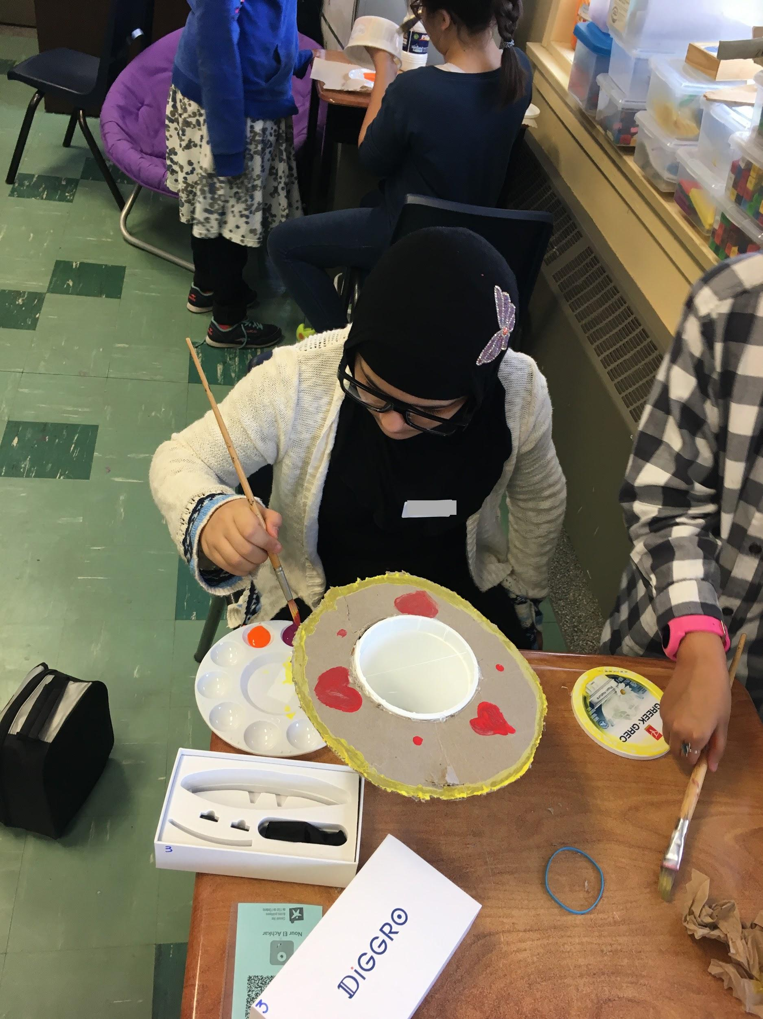
Figure 1. Nalina, wearing her spy glasses as she paints her instrument.

Video data for all participants, including focus participants, were first coded by a research assistant who described, in broad terms, students’ activities in each video segment (e.g., reading online, talking to peers). During a second round, research team members constructed detailed memos of video segments for the focus students. This enabled us to establish common understandings of the data, to discuss what we each saw as important and to identify trends in participants’ literacies practices (Miles, Huberman & Saldaña, 2014). In the third round, we used multiple text reading strategies identified by Cho & Afflerbach (2017) as an a priori coding scheme to identify literacies practices used during students’ first day of project planning, when they were reading online for information and inspiration. We added strategies to the list, based on our data. This allowed us to generate a comprehensive set of literacies practices for all students at this moment in the study and respond to the first research question. The online reading and research practices observed for our three focus students are summarized in Table 2.
We used an open coding approach for the spy-glasses videos recorded during the Maker phase of the project. These videos captured students’ gaze through a diverse set of activities that included picking up, and exploring the design possibilities of recycled materials such as yogurt containers, and paper towel tubes, moving around the classroom, talking to peers and to their teacher, and working to build their instruments using a range of tools -- scissors, exacto knives, and hot glue guns. These video data were used to inform the second research question in this study. Importantly, through cycles of viewing and discussion, we used the idea of the small moment to guide our focus. Informed by Dynamic Systems (Thelen, 2005) and by Wohlwend et al.’s (2017) notion of learning through assemblage, we assumed that meanings and literacies practices would self-organize in the flow of the students’ making. We assumed that interactions and transactions among the learner, their chosen materials, their peers, their teacher, and the evolution of the project goals over time, would look different for every learner, and that the meaning constructed by each learner would emerge from many small choices, actions, and transactions over time. Although we cannot know from these data which moments, specifically, were most important for the students’ construction of meaning, our approach to our video analyses focused on describing the flow of observable actions, choices, and interactions.
Video: Researcher perspective. Once finished, we recorded the students talking about their projects and what they learned using an iPhone camera. These videos were transcribed and analyzed for additional information about the ways they made meaning from their work.
Multimodal tutorials. Students’ digital multimodal tutorials, created in the form of Google Slides Presentations (see Figures 3 and 4 for examples), were used to inform understandings of how students synthesized their maker processes using information, words, images, and graphic elements. These data informed our third research question.
In sum, we analyzed video data of students working and talking about their projects to inform questions 1 and 2; and students’ multimodal compositions to inform our third question.

Results

Nalina : Strategic, Social and Multimodal
Nalina invented a new instrument called the Tamboumara which, as she described in her own words, combines elements of the drum and the maraca. “Tu dois avoir un bâtonnet et quand tu tapes, ça fait le son d’un tambour et quand tu fais ça comme ça [en secouant] ça fait le son d’un maracas. You have to have a stick and when you hit it, it makes the sound of a drum and when you do it like that, [shaking] it sounds like a maracas.”

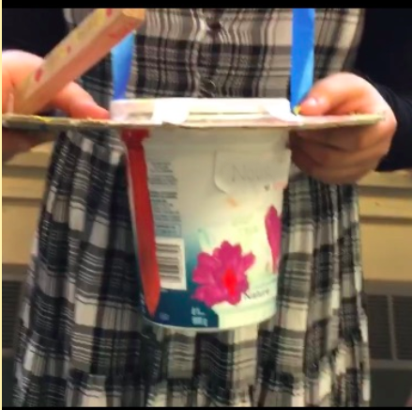
Figure 2. The tamboumara created by Nalina.

Even though she demonstrated intensive focus, practiced a range of strategies during the initial online inquiry phase of this project, and invented a new instrument during her maker process, when asked what she learned during the activity, Nalina said she really was not sure that she had learned anything new. After a pause to reflect, she shrugged and said, “non, je crois pas” [I don’t believe so] suggesting that, based on her own understandings, she worked with skills or ideas that she already knew or had. She reported liking the activity because it was connected to her interest in music, but Nalina did not report feeling challenged by the activity to develop or practice new skills. That said, she demonstrated a range of information gathering and meaning-making practices at every phase of her project.
Online Inquiry. As outlined in the Appendix, Nalina practiced 37 unique strategic actions to gather information and to make meaning from the texts she found and used, at least initially, to inform her Maker project. Overall, Nalina seemed very focused on the task. Her research process was nonlinear, and iterative. New ideas seemed to come to her in the searching. For example, she conducted a query for “how to make a guitar” and then substituted ‘guitar’ for ‘drum’ in the search box. She found crafting blogs, and spent the most time scrolling through user comments about the projects she was considering. She repeatedly placed her cursor on comments, a visual cue to us that she was reading these comments with intention -- perhaps leveraging the network of expertise found in the comments section to inform her plans. Often, Nalina scrolled to the bottom of the comments sections of these sites, and then scrolled slowly back toward the top. She took no notes, but copy-pasted several images into a Google slide deck, presumably to document her planning process and to hold a range of relevant ideas in juxtaposition before she ultimately decided on what to create. Although Nalina paused at times to look around the room, her search process was independent, and very self-contained. Importantly, her online reading and research oriented toward the gathering of personal recommendations from communities of online crafters.
Making. Ultimately, Nalina mixed elements of the drum with elements of a third instrument -- the maraca -- to create a hybrid instrument that she could tap and shake to make music. It is not clear when or how she diverged from the idea of remixing elements of the guitar, although it may have occurred when she saw the materials available to her. The flow of Nalina’s Maker process was most notably punctuated by cycles of collaboration and movement around the classroom. We see Nalina painting the top of her Tamboumara beside a friend, and then with the friend’s help. She makes trips to the materials table and circulates around the classroom, her gaze often fixed on her classmates’ maker processes. She offers a compliment to a friend, watches others as they work. She asks a classmate whether the piece of wood, which ultimately becomes her drumstick, is being used by anyone. She takes it, tests its sound, returns to the hot glue station where she puts the final touches on her instrument design.
Table 2
Nalina’s Maker process
Activities | Materials & Tools
Individual  Watching peers  Cutting, painting, glueing, decorating, sawing  Collaborative  Painting with a friend  Moving, circulating around the classroom  Choosing materials  Checking on the availability of materials  Giving a compliment to a friend  Seeking validation for her work from a friend | Materials  Cardboard  Plastic yogurt container  Paint  Hot glue  Feathers  Ribbon  Marbles  Wood  Tools  Glue gun  Scissors  Paint brush  A saw

Multimodal Tutorial. Nalina’s tutorial includes five slides. Synthesis, curation and integration of ideas, are evident throughout. From the Internet, she located, selected and inserted background and clipart images to communicate meanings (e.g., a lightbulb to show innovative thinking; the piano keyboard to represent music). The tutorial is logical in its organizational structure. She lists required materials and tools, then offers a logical set of how-to instructions for creating her instrument. She even offers a separate set of instructions for cutting the wood to make the drumstick. The instrument she designed, a “tamboumara” was itself a synthesis -- the combination of a drum (tambour) and a maraca. She used layers of images and texts in her multimodal compositions throughout. Notably, on the first slide, she seems to have used the title to visually link the drum (positioned at left) and the maracas (at right), perhaps foreshadowing the way she remixed elements of each to invent the tamboumara. On her final slide, she places images of a lightbulb, drums, a piano keyboard, and musical notes on a blue background that includes a garden of spring daisies blooming. In the placement of these elements, we infer several ideas -- emergence, renewal, beauty at the intersections of these components, all of which include a sensory element. At top right, she includes a question for the reader in a pink speech bubble: “Did you know that the tamboumara doesn’t really exist, because it’s invented? Also, it’s a drum and and a maracas combined!” Here, we see Nalina’s awareness of audience, and evidence, perhaps of her understandings of texts as socially situated, as constructions, and of the transactions between writer and reader. This awareness of meaning making as socially situated was evident in her online reading of user comments on blog posts, and in the way that her gaze fixed on her classmates’ work as she circulated around the classroom, collaborated with a friend, and asked for affirmation of her work.
In three words, we understand Nalina’s literacies practices to be strategic, social, and multimodal.

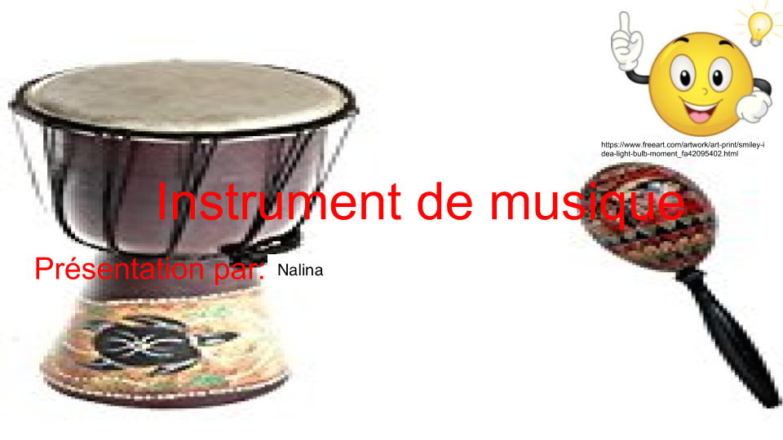
Figure 3. Nalina’s title slide with layers of text and images, a web citation for the happy face lightbulb moment clipart, and the title linking the two instruments visually.

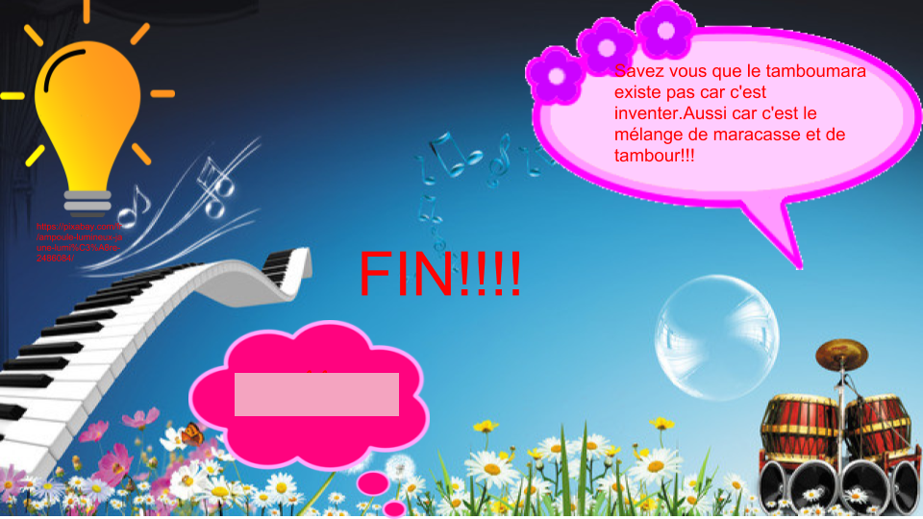
Figure 4. Nalina’s final slide with the speech bubble question for her readers.

Aisha: Socially contingent, careful, and school-ish
Of the three students of focus, Anne-Sophie noted that academically, Aisha was both the most enthusiastic about school and also the most academically oriented. Her enthusiasm and know-how were evident in her interactions with friends, several of whom came to her for advice about the project expectations, and technical advice as they started the project. Ultimately, Aisha created a pan flute using plastic drinking straws, ribbon, decorative feathers, beads and paint. In fact, she created two pan flutes because the first one didn’t work out. When asked what she learned during the process of making her flute, she said, “J’ai appris que si quelque chose ne fonctionne pas tu dois juste recommencer et des fois ça va être juste meilleur que d’autres. I learned that if something does not work you just have to start over and sometimes it's going to be just better than others.” She also said that she liked the project because it allowed her to make something, using “beaucoup de créativité” (a lot of creativity).
Figure 5. Aisha, presenting her pan flute.

Online reading comprehension. Aisha used 42 different strategic practices while searching and gathering ideas for her Maker project. Most notably, she negotiated a range of choices through discussion with friends, and with her teacher. At different moments, she asks a friend to help her decide which image she prefers, asks a friend what she is working on, and shows her teacher the images she has gathered and asks if she’s on the right track. The teacher affirms Aisha, but prompts her to consider the materials she might like to use as well. Anne-Sophie suggests a couple of search phrases she might use, such as “how to make a guitar” or “how to make a violin” as well. Next, Aisha searches Youtube using these exact phrases, but fails to find anything she deems pertinent, noting that “tous ces vidéos ne sont pas bons” (none of these videos are good). Because of her constant interactions with peers in the classroom, Aisha’s online reading and research processes are far from linear. After exploring multiple images and videos, she begins to draw an instrument that is half-violin / half-guitar using paper and pencil. She is the only student to use this approach, but she doesn’t complete it because she is distracted by her peers. This represents an important moment since she uses a different medium, possibly feeling restricted by the format of Google Slides. When Anne-Sophie tells everyone to share their documents, she calls out, 'I didn’t do anything! (in English)'. She tells her friends and decides not to share the document she had been working on with her teacher. Although she used the most strategies of the three students, and was actively engaged in a range of discussions and collaborations, she seems to perceive that she did not do anything worthy of sharing.
Making. In the Makerspace, Aisha works to glue and to paint her pan flute confidently, pausing occasionally in moments that suggest reflection and consideration of how to continue. The pan flute project was not at all where Aisha began her planning in class as she searched for ideas online. Several other girls in the class, however, also decided to create pan flutes. It’s not clear who had the idea first, but at one moment, as Aisha looked for a piece of ribbon to add to her flute, another girl perceives that Aisha is copying her design. Because we see the girl’s face, we can tell that she is unhappy. Aisha explains that she will use her selected piece of ribbon differently, perhaps to reassure her friend that they can both create unique versions of the same basic instrument design. One element of Aisha’s literacies practice in this social context then is to communicate her intentions, and to reassure her friends that she is working in ways that won’t copy or overshadow their work. At another moment, she compares her pan flute with the one her friend has made. She counts the number of straws in her friend’s work, and makes note of the way her friend has decorated the instrument. After this exchange, we see her turn her flute over in her own hands as she waits to reapply hot glue to her instrument. Aisha also helps another friend who seems quite nervous about the glue gun to affix the straws together. Having done it herself, she shares her technique. For this fifth-grader, her Making is clearly inextricable from broader social conventions, constraints and complexities. We wonder how her social positionality shaped her Maker choices and ultimately the ways that she made meaning from her work. At times, for Aisha, we infer that she is making meaning through comparison, through collaboration, through engagement with her peers, through the sharing of her skills and knowledge, and that these practices may all be connected to considerations related to maintaing friendships and how she fits, and is seen to fit, in the social structures of her classroom.

Table 3
Aisha’s Maker process
Activities | Materials & Tools
Individual  Watching peers  Cutting, painting, glueing, decorating  Collaborative  Helping friends  Negotiating  Moving, circulating around the classroom  Choosing materials | Materials  Plastic drinking straws  Hot glue  Feathers  Paint  Decorative beads  Ribbon  Tools  Glue gun  Scissors  Paint brush

Multimodal tutorial. Consistent with Nalina’s work, Aisha’s multimodal tutorial also includes five slides. She begins with the list of her materials and provides ten step-by-step instructions using words and images to demonstrate the process. Her tutorial is colourful -- each instruction is written in a different colour, perhaps to emphasize that each step is different, or additive in the process. The images are copied from the web, demonstrating her ability to find relevant images, copy them, and position them to support or extend the meanings in her instructions. She demonstrates awareness of audience by using the imperative tense, and includes a call-out voice bubble with interesting facts about the pan flute. Although she provides no reference for the information she writes in the “did you know” bubble, she does provide a link to a YouTube video where readers could see someone make a pan flute using the same methods Aisha outlines.

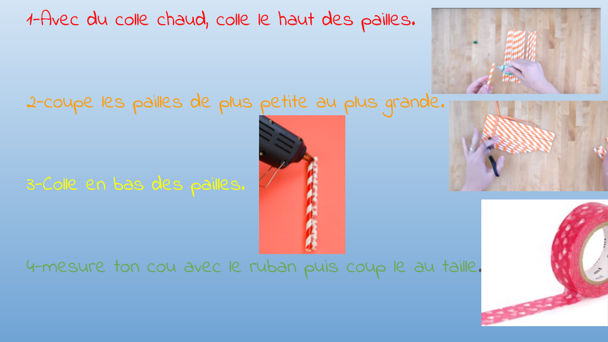
Figure 6. Aisha’s slide with instructions for making a pan flute.
Translation : 1-With hot glue, glue the top of the straws.
2-cut the straws from smallest to biggest.
3-Glue the bottom of the straws.
4-measure your neck with the ribbon and then cut it to size.

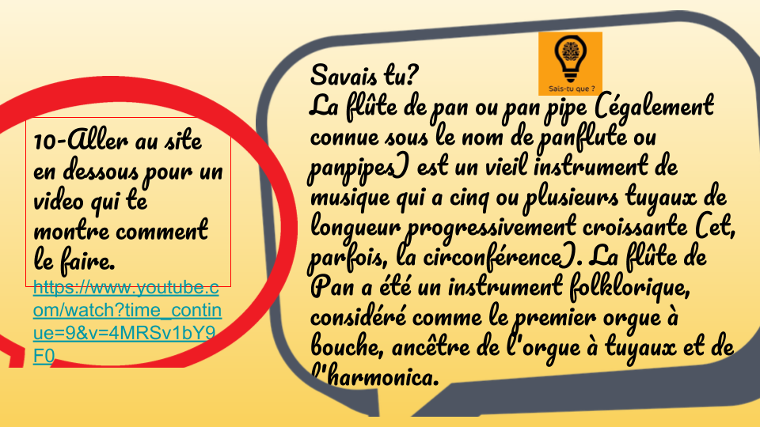
Figure 7. Aisha’s slide with a “do you know” bubble
Translation : 10-Go to the site below for a video that shows you how to do it.
https://www.youtube.com/watch?time_continue=9&v=4MRSv1bY9F0

Did you know?
The pan flute or pan pipe (also known as panflute or panpipes) is an old musical instrument that has five or more pipes of progressively increasing length (and, sometimes, circumference). The Pan flute was a folk instrument, considered the first mouth organ, ancestor of the pipe organ and harmonica.

Overall, we might describe Aisha’s literacies practices as socially contingent, careful and school-ish. As she started exploring possibilities online, Aisha sought out teacher affirmation, an indicator that she was seeking to do this work “correctly”. It is interesting to note that of the three students studied, Aisha designed a pan flute following a method that was already published online. Moreover, the project was a popular one among the girls in the class; three other students made the same type of instrument. Although she began by exploring multiple possibilities and even began to draw an invented instrument, suggesting an initial interest in creating an original design, she abandoned these ideas for a project that was proven, for which there were already online tutorials to follow, and that positioned her in a community of other girls who also decided to make Pan flutes. Aisha was technically confident as she made her instrument. She readily helped others during the online research and Maker processes, but did she lack confidence as a designer? Even though she was very able to communicate verbally with peers, to describe her work and to create a multimodal tutorial that was logical using a range of skills and text sources, these data lead us to wonder whether Aisha was less confident in her ability to create something unique and completely new, or whether the importance of belonging and interacting with friends during the Making was a principal determinant of her choices.

Noah: Design driven, verbal and embodied
Noah made a tangour -- an instrument of his own invention, inspired somewhat by a web image that he reported seeing. The tangour, like Nalina’s tamboumara, combines elements of two instruments. For Noah, his instrument is part drum and part guitar. In meticulous detail, Noah described every design choice he made, noting that he chose to use the juice container because, “tout le monde faisait la même chose mais personne n’utilisait une boîte de jus pour la guitare, alors, je voulais faire original. Everyone was doing the same thing but nobody used a juice box for their guitar, so I wanted to do something original”. Of the three focus students, Noah’s print-based and digital literacies seem to be the least well developed (corroborated by his teachers), but he found Making with all of the physical materials to be easy. He said that he learned “que c’est facile d’être original avec tout le matériel là-bas. [I learned] that it’s easy to be original with all the material out there.” Clearly proud of his musical instrument, he also noted that he liked the activity because he could use his “imagin, imagi -- um, notre tête pour faire qu’est-ce qu’on voulait. Imagin, ima, -- um our head to make what we wanted.” In this response, we hear that Noah appreciated the agency he was afforded during this activity to create something based on his own ideas and imagination.

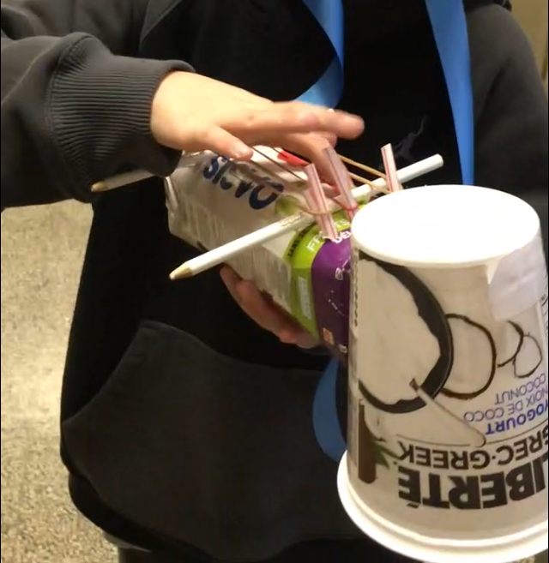
Figure 8. Noah and his Tangour.

Online research. Although he suggested he had seen an image of a tangour (perhaps on the screen of a friend), Noah did not conduct any meaningful online reading or research during the initial phase of his Maker project. He opened his Chromebook, but rather than set to work reading and researching, he started by asking Anne-Sophie about what he was supposed to do, and then expressed openly that he understood the instructions. His research time included conversations with his friends, watching his teacher as she answered other students’ questions, and then explaining to Anne-Sophie that he had decided to make a tangour, an instrument that is a drum and a guitar, all in one. When she responds saying, “Je n’ai jamais entendu parlé de ça I’ve never heard of that” he answers, “non, j’invente” No, I’m inventing. Next, he describes his plan to the educational assistant in the room, talks to a friend about his plan, helps the friend spell a word, and offers the friend ideas for how he might make a guitar. When Anne-Sophie calls out to the class that they should be keeping track of their information sources, Noah says that he took no information from the Internet at all. Raher, all of his ideas came from his head.
Maker process. Although he opted into the reseach study, Noah didn’t wear the video glasses during the maker phase of his project. He did, however, provide a detailed description of his process and during the activities, we captured photographs of him working. Although we did not capture his first-person gaze, we do have video of him working intensively and with focus on his project, as other boys around him were sawing wood, or talking loudly. From Noah’s video description of his work, the most notable meaning making process seems to be in the way he judged each element for its feasibility, structural soundness, aesthetic qualities and music-making potential. Strumming on the elastics, he explained, “Il y a des élastiques pour comme, faire du bruit [...] et ça (touchant les crayons qu’il a placés en dessous des élastiques pour les retenir en place) c’est pour faire le bruit, sinon, (touchant les élastiques) ça fait bouger, et ne fait rien. There are elastics for like, making noise and this (pointing to the pencils that he placed under the elastic “strings” to hold them away from the juice box and create tension in the bands), this is for making noise because if not, these just move and do nothing (pointing to the elastic bands).” Although Noah was not able to articulate exactly how the pencils worked to enable the elastic bands to both stay in place and generate sound, he had clearly found, through a process of iterative prototyping, that he needed a way to keep the elastics in place and strung tightly enough that they would vibrate when strummed.
We also heard evidence of prototyping as he explained, and simultaneously demonstrated, how the neck strap he designed allowed him to play the drum with one hand while also strumming the guitar strings with the other. “Je peux l’avoir en main et faire ça (en tappant le tambour) et ça (en grattant les cordes de la guitare) en même temps, au lieu de faire comme ça (en tenant l’instrument avec sa main), tu dois arrêter et faire comme ça, quand tu le fais (démontre chaque technique individuellement). I can have it in my hand and do this (taps the guitar) and this (strums the guitar strings) at the same time, instead of stopping and doing like this, when you do it (shows each technique invidually).”
He also added a “neck” to his guitar by bundling some drinking straws together, inserting them into the hole in the top of his juice box, and tieing them them together with an elastic band. He mentioned that he included this detail so that “ça c’est pour que ça ressemble à une guitar. This is so that it looks like a guitar.” Plus, he explained that he looked for materials for his drum that would make the loudest noise. In fact, he also discovered that he had to change his tapping technique to generate the most sound from the yogurt container he ultimately chose.

Table 4
Noah’s Maker process
Activities | Materials & Tools
Individual  Watching peers  Cutting, affixing  Testing a range of techniques for making music with his instrument (prototyping)  Collaborative  Talking to peers  Choosing materials  Moving, circulating around the classroom | Materials  Juice container  Elastic bands  Yogurt container  Pencils  Drinking straws  Ribbon  Tape  Hot glue  Tools  Glue gun  Scissors  Paint brush

Multimodal tutorial. Noah’s tutorial includes four slides. Although he changes the font colour from slide to slide, there are no images, no backgrounds, no links, or other multimodal elements in his work. Further, he seems to have based his project on his own ideas rather than on information gathered from online information sources. Unlike Nalina and Aisha who demonstrate an awareness of audience in their work, Noah uses “je” (I) to explain what he did to make the tangour, seemingly unaware that this tutorial could be read by others for instructions on how to make this unique instrument. He offers no list of materials, but he does mention that the tangour is the instrument of the future on slide two. By 2027, he notes that this instrument will be used by “toule grande chanter come assne,big shaq,shane mendez,biber all of the big singers including assne, shaq, shawn mendez, biber (sic)”.
His list of instructions on slide four seems to reflect memories for some of what he did (I will go to the table and tap on all of the materials; I will choose the one that makes the loudest noise; I will make a guitar; I will watch videos on how to make a guitar; I have to make a hole; I have to use elastics), but his written instructions are much less detailed than the verbal description he gave of his design process which, importantly, he provided while holding his instrument. Like Hina’s ‘tamboumara’ Noah’s tangour in inherently synthetic. However, he seemed unable to organize and articulate a set of clear steps for creating his tangour using both images and text, evidence that Noah is much earlier in his learning for multimodal composition than Aisha and Nalina.
In sum, Noah’s literacies practices are design driven, verbal, and embodied. His design choices, seemed motivated by concerns for the way each component would function, and for how the musician would interact with these components to make music. Before choosing the yogurt container, for example, he tapped on all of the available containers on the materials table to find the one that would make the best noise. He tested and refined his tapping techniques. He discovered that the elastics needed to be held in place because otherwise, they would not make any sound. For Noah, the meaning in this work and his most powerful descriptions of his learning seemed rooted in his sensory interactions with his instrument as he crafted it. For Noah, more than was evident for Aisha and Nalina, his literacies practices were deeply enmeshed and embodied in his making, easiest to communicate verbally as he held the instrument and described each of his choices. Retrospectively, he was not able to transfer this thinking to the multimodal slide deck. In addition to there being sparse evidence of multimodal synthesis of meaming in his text-based work, there were logical gaps in his instructions.

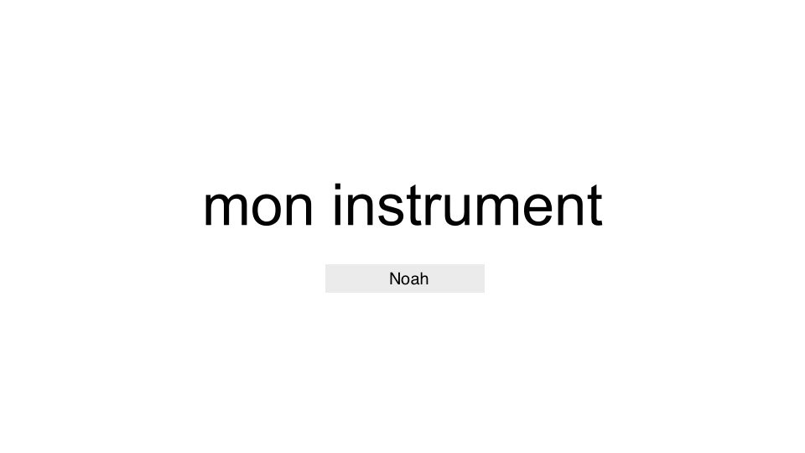

Figure 9. Noah’s title slide.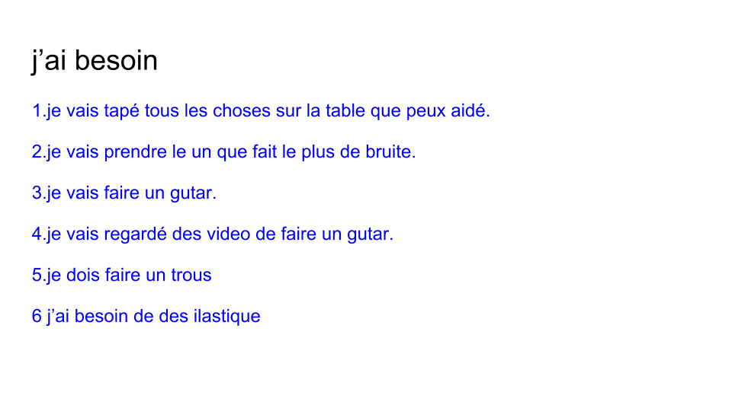
Figure 10. Noah’s instruction slide.

Discussion
To prepare children for the complexities of meaning making in diverse, dynamic and networked information landscapes, we began this article with the assertion that literacies practices should more often be situated in work that encourages children to set their own priorities, seek out information that serves their purposes, and requires them to leverage a range of digital and print-based literacies skills to communicate their understandings (Hughes, Morrison, Mamolo, Laffier & de Castell, 2018). Further, in a post-truth era, it seems especially important to create learning conditions, in school, that allow children to develop evaluativist epistemologies and dispositions so that they might come to understand knowledges as constructed, as shaped by human perspectives, and as contingent. When children adopt this critical positionality in relation to texts, they are more able to synthesize meanings across multiple, multimodal information sources, identify biases, and construct more nuanced understandings of complex issues (Barzilai & Zohar, 2012; Barzilai & Ka’adan, 2017).
As noted, one instructional approach that may empower learners with a deep sense of agency as they solve and communicate solutions to complex problems is Making (Clapp, Ross, O. Ryan & Tishman, 2017; Halverson & Sheridan, 2014; Martin, 2015; Rowsell & Shillitoe, 2019; Vossoughi, Hooper & Escudé, 2016; Woodard, 2019). As a dynamic, productive process of bricolage, Making may be an appropriate approach for introducing and practicing complex literacies with bilingual and multilingual children in an urban, Canadian context, because it is inherently sensory and grounded (Barsalou, 2010). Indeed, current conceptions of Maker literacies suggest that meaning is constructed during physical-material interactions (Wohlwend, Scott, Yi, Deliman & Kargin, 2018; Rowsell & Shillitoe, 2019; Wargo, 2018; Woodard, 2019) and that multimodal composition, as a way of showing the meanings constructed, may serve the literacies learning needs of multilingual children living in lower-income contexts (e.g., Smith, 2014).
In this study we sought to describe the layered literacies practices of three students as they moved through each of three phases of an interdisciplinary Maker project that included elements of online inquiry, physical bricolage and multimodal composition while also addressing expectations in the provincial music and literacies curricula for Grade 5.
The first phase of the project was meant to be about gathering ideas from diverse online sources and making a plan for the building of a musical instrument. The second phase was about turning initial plans and ideas into reality through Making. Using recycled materials, the students created musical instruments. The third phase was about creating a multimodal slide deck that could be shared with anyone interested in learning how to recreate the student’s musical instrument. This part of the task required students to summarize their materials list, organize the steps of their maker process logically, and explain each step in their process using words, colour, images, videos, and/or hyperlinks.
Next, we outline findings framed by our three research questions, consider implications and next steps.
RQ1: What online reading and research strategies does the student use during the planning phase of the Maker project?
From our analyses, we see that Nalina, Aisha and Noah enacted and used unique constellations of strategic practices as they initially looking for ideas online and offline. Informed by previous research (e.g., Cho & Afflerbach, 2017), we categorized the practices into five broad groupings: planning, (re)searching, selecting, evaluating and synthesizing. Within these, Nalina and Aisha were more active in their online information search using 37 and 42 unique strategic practices respectively; Noah used only three practices, two for his initial planning and one as he tried to orient his search process. None of Noah’s literacies practices during this phase included using the Internet to find or gather information. His Maker project idea seemed to crystallize through conversation with classmates, and individual rumination rather than from information search. Nalina, on the other hand, looked for blogs and, in particular, user comments. Throughout this phase she copy-pasted potential ideas into a Google doc to curate resources and perspectives from an online community of Makers. She was intentional and purposeful in her gathering and reading. For Aisha, the search process was interrupted by questions from peers, and divergent in that she seemed to go in several directions. At the end of the time period, she claimed that she had found nothing pertinent. Although able to find information and navigate the web, Aisha’s search process was ultimately less focused and productive than she seemed to have wanted it to be, raising the point that more information search strategies -- particularly as students determine texts to read -- may indicate unproductive cycling, rather than a focused, intentional process of comparing possibilities or deciding what to do. Given that Aisha ultimately created a pan flute that had not been part of her initial thinking process and that Noah didn’t use the Internet at all to generate ideas, these examples lead us to wonder whether, for some fifth grade students, the complexities of online search before Making may be too open, or too unstructured to offer the type of idea generation that we hypothesized would happen for them during this phase of the work. In some cases, for fifth graders, the best ideas may come from imagining and re-imaginging the possibilities in conversation with friends, or in the Making itself, rather than through a Google images or YouTube search. For Nalina, who seemed to understand the relevance of user insights or community perspectives, as curated in the user comments on crafting blogs, the online search enabled her to generate ideas.
Our analyses of these students’ search processes lead us to wonder whether it might be more beneficial for some students to use online search for technical supports, or to seek out ideas only once they have seen and touched the Maker materials and imagined their design affordances. Further research on this question is needed to more fully explore the ways that online search does and does not enable fifth graders to explore new ideas as they consider possibilities for Maker ideas on the open web. For some it may have been a hindrance; for others, it offered a network of possibilities and insights.

RQ2: What literacies practices are evident as the student builds a musical instrument from recycled materials?
For all three students, we saw both individual and collaborative layers in their meaning making process. For all of them, interactions with peers, whether in conversation, through collaboration to complete a task or refine a technique, or during careful observation of others’ activities, seemed fundamental to their processes of bricolage. All of the students walked around the space, watching and interacting with their peers and with the materials at the materials table. Nalina offered compliments to others and asked for affirmation of her work from others too, suggesting that a certain amount of socially situated approval was part of her process. For Aisha, creating a pan flute, as other girls were also doing, meant she had to negotiate and justify her use of materials in an original way. This exchange, though brief, leads us to wonder about about the ways social conventions and constraints shape fifth graders’ literacies practices during Maker activities. We conceptualized them as open, democratic, and as opportunities for developing agency and understanding knowledges as assembled, but for children at this age, to what extent do the social structures of a community impinge on these objectives? More research is needed to explore this question. Nalina and Noah seemed empowered to create something unique; Aisha chose to follow a set of established crafting instructions and join in with a group of students making the same type of flute. It is not clear from our data why, or how the students’ design choices reflect their social orientations or positionality.
All three of the students demonstrated to us how their musical instruments made sound, reflecting an embodied understanding of their design process. The purposeful, iterative assemblage of their chosen materials resulted, in all three cases, in instruments that, when used in particular ways -- tapping, shaking, strumming, blowing across the tops of drinking straw“pipes” -- they could generate sounds. For teachers, these embodied literacies may be easy to overlook. We assert that for all participants, their ability to demonstrate the production of sound was also a demonstration of their understanding – an understanding situated in their instruments, in their bodies, and in their interactions. The instruments themselves are the meanings made.

RQ3: What evidence of multimodal synthesis is visible in the student’s digital composition?
We used students’ multimodal compositions to inform understandings of the ways they integrated meanings across modes to communicate their Maker processes. As we begin to understand the literacies practices afforded by the multimodal design and redesign of understandings through making and composition (New London Group, 1996; Smith, 2014) we looked for layers of meaning in the Google slides presentations that the children produced. Given our wonderings about the potential for embodied, physical and multimodal digital Making as a way to introduce more abstract multiple text integration processes, and support development of critical, evalutivist dispositions (Barzilai & Zohar, 2012) we looked for evidence of meaning assemblages in these artifacts.
For Nalina and Aisha, multiple, integrated modes of meaning are present in their work. Both girls used images, colour, text, spatial orientation, hyperlinks, ordered lists, graphic elements such as speech call-out bubbles, and emoticons to communicate their Maker processes for an assumed audience of other Makers. Nalina’s title page is especially suggestive of layered, integrative meaning through multimodal composition. On it, her title, “Instrument de musique” is placed in a way that connects the image of the drum at left with the image of the maraca at right, foregrounding her instrumental remix. Without interview data to inform understandings of the girls’ design and composition intentions, we can only infer meanings from their work, but it seems that both students layered modes to convey integrated meanings.
Noah, however, used only words and colour changes to the font in his slides. We see no representation of his design process in images, hyperlinks, embedded video or choice of background template. And yet, his ability to communicate the way that his design came together, the way that he integrated elements of the guitar and the drum verbally was remarkable. For Noah, it seems that synthesis is inherent in his instrument. The transfer of his embodied understandings of his design process to the digital context may have presented barriers, however.
Does this apparent barrier reflect a disconnect between different modes of meaning making - the digital-textual and the physical-textual? We wonder if Noah’s instructions might have been more coherent had he been able to write while holding his instrument in his hands? This question deserves further research. For teachers, it is important to consider the ways that meaning and understanding of both disciplinary and design processes are situated in the physical products that students invent or create. The abstraction to the digital, multimodal representation of these processes may, in fact, be interrupted if access to the physical object is restricted during the composition phase of projects like this one.
Looking across these three students’ literacies practices through the three phases of this project, our analyses showed that Nalina, Aisha and Noah did make meanings in diverse ways (see Table 5). During information search, we identified five broad categories of strategic activity with a range of nuanced practices in each. During Making, we observed a flow of individual and collaborative meaning making practices that were suggestive of meaningful assemblage (Wohlwend et al, 2017), embodied design and redesign (New London Group, 1996). During the final composition phase, Aisha and Nalina’s work showed synthesis of their Maker process, and use of multiple modes to communicate meaning (e.g., Smith, 2019). At different moments for all of the participants, collaborations, conversations and comparisons with peers and with their teacher seemed important to their decision making. More research is needed, however, to understand the ways that social interactions shape students’ design choices and the meanings they construct from their socially situated work.

Table 5
Layered literacies practices.
Task Phase/Purpose | Literacies Practices
Multimodal Composition | Step-by-step instructions  Use of images, colour, spatial placement of text and graphic elements to communicate synthetic meanings with words  Use of graphic elements (e.g, speech bubble) in consideration of audience
Making | Individual  Watching peers  Cutting, affixing, painting, glueing, decorating  Testing a range of techniques for making music with the instrument (prototyping)  Collaborative  Helping friends  Talking to peers  Choosing materials  Moving, circulating around the classroom  Negotiating  Moving, circulating around the classroom  Choosing materials
Online Information Search | Planning  (Re)Searching  Selecting  Evaluation  Synthesizing
The next phases of research must also explore whether, or to what extent, bilingual and multilingual children attending French-language public schools in this and other urban Canadian contexts, and who practice integrated, interdisciplinary Maker activities like the one we observed, trasfer their embodied practices of bricolage to meaning making with multiple information sources. Certainly, we saw evidence of information gathering and of synthesis in students’ work – but does Making prepare children to view all texts (printed, digital, physical, multimodal) as constructed? Does the development of Maker agency (Clapp et al., 2017) prepare children to develop agency as bricoleurs in other domains of their literacies practices, for example with multiple information sources gathered from the Internet? As we look for ways to support learners’ development of the fundamental literacies that will enable them to be critical, evaluative consumers, producers and participants in all of the literacies spaces of their lives, we assert that Making with moments for strategic online search and multimodal composition can offer fifth grade children an opportunity to begin.
Importantly, our findings suggest that teachers should not assume that online search will necessarily enable idea generation for all young Makers. Rather, online search may be best leveraged only after children have seen, touched and explored the design affordances of the materials they could use (Clapp et al., 2016). Further, based on our observations, multimodal composition grounded in Making should not be a retrospective exercise in remembering a process that is dissociated from the embodied cognition situated in the child’s creative work. Even if the Making happens in a room separate from the classroom (i.e., a Makerspace) Noah showed us that children’s ability to demonstrate understandings of their processes and designs may be much more complex while holding, showing and talking about their work than in a slideshow or other document.

Limitations
In relation to its student-centered and multimodal design, this study knew a variety of methodological limitations. Ethically, it was important for our team to make sure that students who had consented to participate in this study had the option to choose at each step, to opt in or out of participating in the study or using our research equipment. For this reason, some students opted not to wear the spy glasses for part of their digital or physical Making activities or not to do a short video interview with a member of our research team. Moreover, not all students completed the multimodal tutorials that were at the heart of this Maker project. For these reasons, many of our data sets were incomplete, which led to analysis of fewer students’ practices than previously anticipated.

Conclusion
This study contributes new data on the ways that bilingual and multilingual fifth-grade students living in an urban community in Canada assembled meanings through phases of a Maker project using layered literacies practices. As we seek out ways to prepare children for the complexities of meaning making in a post-truth world, we understand that they will need to develop critical dispositions and epistemologies (e.g., Barzilai & Zohar, 2012). To create opportunities for development of these orientations and skills, teachers in Ontario are designing learning activities that position children as knowledge makers, as bricoleurs, as designers and assemblers of materals and ideas. As in this study, these projects can integrate elements of personal online inquiry (Coiro et al., 2016) with Making (Clapp et al., 2016; Wohlwend et al., 2017) and multimodal composition (Dalton, 2012; Smith, 2014, 2019). This study offers insight into what students do as they make meaning through each phase of this work, while also challenging assumptions about the role of digital activites such as online search and multimodal composition in relation to the physical, sensory, design-driven practices in which the children engaged. Although digital tools may afford access to networks of ideas, and create the space for a multimodal retelling of a process, for some children in Grade 5, meanings are made through conversation, collaborative exchange and through opportunities to show and tell how meanings emerged in their making.

This research was supported by a Social Sciences and Humanities Research Council of Canada’s Insight Grant to Janette M. Hughes, PI and Michelle Schira Hagerman and Megan Cotnam-Kappel, Collaborators. We thank our collaborators deeply, and particularly the participants for making this work possible. We also acknowledge that this research was conducted on the unceded territories of the Algonquin peoples.

References

Barab, S., & Squire, K. (2004). Design-based research: Putting a stake in the ground. Journal of the Learning Sciences, 13(1), 1-14. https://doi.org/10.1207/s15327809jls1301_1
Barsalou, L.W. (2010). Grounded cognition: Past, present, and future. Topics in Cognitive Science, 2, 716-724.
Barzilai, S., & Ka’adan, I. (2017). Learning to integrate divergent information sources: the interplay of epistemic cognition and epistemic metacognition. Metacognition and Learning, 12(2), 193–232. http://doi.org/10.1007/s11409-016-9165-7
Barzilai, S., & Strømsø, H.I. (2018). Individual differences in multiple document comprehension. In J.L.G. Braasch, I. Bråten & M. McCrudden (Eds.) Handbook of multiple source use (pp. 99-116). New York: Routledge.
Barzilai, S., & Zohar, A. (2012). Epistemic thinking in action: Evaluating and integrating online sources. Cognition and Instruction, 30(1), 39–85. http://doi.org/10.1080/07370008.2011.636495
Barzilai, S., Zohar, A. R., & Mor-Hagani, S. (2018). Promoting Integration of Multiple Texts: a Review of Instructional Approaches and Practices. Educational Psychology Review, 1–27. http://doi.org/10.1007/s10648-018-9436-8
Braasch, J. L. G., Bråten, I., Strømsø, H. I., Anmarkrud, Ø., & Ferguson, L. E. (2013). Promoting secondary school students’ evaluation of source features of multiple documents. Contemporary Educational Psychology, 38(3), 180–195. http://doi.org/10.1016/j.cedpsych.2013.03.003
Chaput, M., & Champagne, A. (2012). Rapport du Comité sénatorial permanent des langues officielles: Internet, nouveaux médias et médias sociaux. Ottawa, ON, pp. 72-118. Retrieved from https://sencanada.ca/content/sen/Committee/411/OLLO/rep/rep05oct12-F.pdf
Cho, B.-Y., Woodward, L., Li, D., & Barlow, W. (2017). Examining adolescents’ strategic processing during online reading with a question-generating task. Advance Online Publication. American Educational Research Journal, 54(4), 691–724. doi: 10.3102/0002831217701694.
Cho, B.-Y., Afflerbach, P., & Han, H. (2018). Strategic processing in accessing, comprehending, and using multiple sources. In J. Braasch, I. Bråten, & M. McCrudden (Eds.), Handbook of multiple source use. London, UK: Routledge.
Cho, B.-Y., & Afflerbach, P. (2017). An evolving perspective of constructively responsive reading comprehension strategies in multilayered digital text environments. In S. Israel (Ed.), Handbook of Research on Reading Comprehension, Second Edition (pp. 109-134). New York, NY: Guilford Publications.
Clapp, E., Ross, J., O. Ryan, J., & Tishman, S. (2016). Maker-Centered learning: Empowering young people to shape their worlds. San Francisco, CA: Jossey-Bass.
Coiro, J., Castek, J., & Quinn, D. (2016). Personal inquiry and online research: Connecting learners in ways that matter. The Reading Teacher, 69(5), 483-492.
Coiro, J., & Dobler, E. (2007). Exploring the online reading comprehension strategies used by sixth-grade skilled readers to search for and locate information on the Internet. Reading Research Quarterly, 42(2), 214–257. http://doi.org/10.1598/RRQ.42.2.2
Cotnam-Kappel, M. (2014). Remixing Graffiti: Curriculum, Corsican Language, Reflexivity and Critical Pedagogy. Journal of the Canadian Association for Curriculum Studies, 11(2), 44-74. Retrieved from http://pi.library.yorku.ca/ojs/index.php/jcacs/article/viewFile/36768/34544
Cowley, P., & Easton, S. T. (2017). Report card on Ontario’s elementary schools. Toronto, ON: Fraser Institute. Retrieved from https://www.fraserinstitute.org/studies/report-card-on-ontarios-elementary-schools-2017
Dalton, B. (2012). Multimodal composition and the common core state standards. The Reading Teacher 66(4), 333-359. https://doi.org/10.1002/TRTR.01129
De Bot, K. (2008). Introduction: Second Language Development as a Dynamic Process. The Modern Language Journal, 92(2), 166–178. http://doi.org/10.1111/j.1540-4781.2008.00712.x
Education Quality and Accountability Office (2018). Provincial assessment results. Retrieved from http://www.eqao.com/en/assessments/results
Ferrer, E., McArdle, J. J., Shaywitz, B. A, Holahan, J. M., Marchione, K., & Shaywitz, S. E. (2007). Longitudinal models of developmental dynamics between reading and cognition from childhood to adolescence. Developmental Psychology, 43(6), 1460–73. http://doi.org/10.1037/0012-1649.43.6.1460
Fullan, M., & Scott, G. (2014). New pedagogies for deep learning white paper: Education PLUS. Seattle: Collaborative Impact SPC.
Fullan, M., Quinn, J., & McEachen, J. (2018). Deep learning: Engage the world change the world. Thousand Oaks: Sage Publications.
Glenberg, A. (2010). Embodiment as a unifying perspective for psychology. WIREs Cognitive Science, 1(4), 586-596. https://doi.org/10.1002/wcs.55
Kafai, Y., Fields, D., & Searle, K. A. (2014). Electronic textiles as disruptive designs: Supporting and challenging maker activities in schools. Harvard Educational Review, 84(4), 532–557.
Larsen-Freeman, D., & Cameron, L. (2008). Research Methodology on Language Development from a Complex Systems Perspective. The Modern Language Journal, 92(2), 200–213. http://doi.org/10.1111/j.1540-4781.2008.00714.x
Leu, D. J., Kinzer, C. K., Coiro, J., Castek, J., & Henry, L. A. (2013). New Literacies : A Dual-Level Theory of the Changing Nature of Literacy, Instruction, and Assessment. In D. E. Alvermann, N. J. Unrau, & R. B. Ruddell (Eds.), Theoretical models and processes of reading (6th ed., pp. 1150–1181). Newark, DE: International Reading Association.
List, A., & Alexander, P. A. (2018). Cold and warm perspectives on the cognitive affective engagement model of multiple source use. In J.L.G. Braasch, I. Bråten & M. McCrudden (Eds.) Handbook of multiple source use (pp. 34-54). New York: Routledge.
Hagerman, M.S. (2017a). Disrupting students’ online reading and research habits: The LINKS intervention and its impact on multiple Internet text integration processes. Journal of Literacy and Technology, 18(1), 105-156. Retrieved from http://www.literacyandtechnology.org/uploads/1/3/6/8/136889/jlt_v18_1_hagerman.pdf
Hagerman, M. S. (2017b). Les bricoscientifiques: Exploring the intersections of disciplinary, digital and maker literacies in a franco-ontarian school. Journal of Adolescent and Adult Literacy, 61(3), 319-325. https://doi.org/10.1002/jaal.699

Hagerman, M. S., & Cotnam-Kappel, M. (in press). Making as embodied learning: Rethinking the importance of movement for learning with digital and physical tools. Education Review.
Halverson, E. R., & Sheridan, K. (2014). The maker movement in education. Harvard Educational Review, 84(4), 495–505. http://doi.org/10.17763/haer.84.4.34j1g68140382063
Hartman, D. K., Hagerman, M. S., & Leu, D.J. (2018). Toward a new literacies perspective of synthesis: Multiple source meaning construction. In J.L.G. Braasch, I. Bråten & M. McCrudden (Eds.) Handbook of multiple source use (pp. 55-78). New York: Routledge.
Honeyford, M. A. (2014). From aquí and allá: Symbolic convergence in the multimodal literacy practices of adolescent immigrant students. Journal of Literacy Research, 46(2), 194–233. doi: 10.1177/1086296X14534180
Hughes, J., Morrison, L, Mamolo, A., Laffier, J., & de Castell, S. (2018). Addressing bullying through critical making. British Journal of Educational Technology, 50(1), 309-325. https://doi.org/10.1111/bjet.12714
Kahne, J., Hodgin, E., & Eidman-Aadahl, E. (2016). Redesigning civic education for the digital age: Participatory politics and the pursuit of democratic engagement. Theory & Research in Social Education, 44(1), 1–35. http://doi.org/10.1080/00933104.2015.1132646
Martin, L. (2015). The promise of the maker movement for education. Journal of Pre College Engineering Education Research (J-PEER), 5(1), 30-39.
Melo, M. (2016, March). Writing is Making: Maker Culture and Embodied Learning in the Composition Classroom. Digital Rhetoric Collaborative (DRC). Retrieved from http://www.digitalrhetoriccollaborative.org/2016/03/04/writing-is-making-maker-culture-and-embodied-learning-in-the-composition-classroom/
Miles, M.B., Huberman, A. M., & Saldaña, J. (2014). Qualitative data analysis: A methods sourcebook (3rd ed.) Los Angeles: Sage.
Ontario Ministry of Education. (2018). School information finder. Retrieved from http://www.edu.gov.on.ca/eng/sift/
Reinking, D., & Bradley, B. A. (2008). Formative and design experiments: Approaches to language and literacy research. (D. S. Strickland, C. Genishi, & D. Alvermann, Eds.). New York: Teachers College Press and National Conference on Research in Language and Literacy (NCRLL).
Rowsell, J., & Shillitoe, M. (2019). The craftivists: Pushing for affective, materially informed pedagogy. British Journal of Educational Technology. http://doi.org/10.1111/bjet.12773
Statistics Canada (2013). Skills in Canada: First Results from the Programme for the International Assessment of Adult Competencies (PIAAC). Statistics Canada Catalogue no. 89-555-X. Ottawa. Retrieved from http://www.statcan.gc.ca/pub/89-555-x/89-555-x2013001-eng.pdf
Smith, B. E. (2014). Beyond Words: A Review of Research on Adolescents and Multimodal Composition. In R. Ferdig, & K. Pytash (Eds.), Exploring Multimodal Composition and Digital Writing (pp. 1-19). Hershey, PA: IGI Global. doi:10.4018/978-1-4666-4345-1.ch001
Smith, L. B., & Thelen, E. (2003). Development as a dynamic system. Trends in Cognitive Sciences, 7(8), 343–348.
Stewart, S., Riecken, T., Scott, T., Tanaka, M., & Riecken, J. (2008). Expanding health literacy: Indigenous youth creating videos. Journal of Health Psychology, 13(2), 180–189. doi: 10.1177/1359105307086709
Tan, V., Keune, A., & Peppler, K. (2017). The materiality of design in e-textiles. In S. Goldman & Z. Kabayadondo (Eds) Taking Design Thinking to School: How the Technology of Design Can Transform Teachers, Learners, and Classrooms. New York, NY: Routledge. Retrieved from http://kpeppler.com/Docs/2017_MaterialityOfDesign.pdf
Vossoughi, S., Hooper, P. K. & Escudé, M. (2016). Making Through the Lens of Culture and Power: Toward Transformative Visions for Educational Equity. Harvard Educational Review: Summer 2016, 86(2), 206-232. https://doi.org/10.17763/0017-8055.86.2.206
Wargo, J. M. (2018). Writing With Wearables? Young Children’s Intra-Active Authoring and the Sounds of Emplaced Invention. Journal of Literacy Research. http://doi.org/10.1177/1086296X18802880
Westheimer, J. (2015). What kind of citizen? Educating our children for the common good. New York: Teachers College Press.
Wohlwend, K. E., Peppler, K. A., Keune, A., & Thompson, N. (2017). Making sense and nonsense: Comparing mediated discourse and agential realist approaches to materiality in a preschool makerspace. Journal of Early Childhood Literacy, 17(3), 444–462. https://doi.org/10.1177/1468798417712066
Wohlwend K. E., Scott J. A., Yi J. H., Deliman A., Kargin, T. (2018). Hacking Toys and Remixing Media: Integrating Maker Literacies into Early Childhood Teacher Education. In S. Danby., M. Fleer C. Davidson, & M. Hatzigianni M. (Eds.) Digital childhoods: Technologies and children’s everyday lives (Vol. 22, pp. 147-164). Singapore: Springer.
Woodard, R. (2019). Teacher–writer–crafter–maker: an exploration of how making mattered for one writing teacher. Literacy, 1-9. https://doi.org/10.1111/lit.12179
Zhang, S., & Duke, N. K. (2008). Strategies for Internet reading with different reading purposes: A descriptive study of twelve good Internet readers. Journal of Literacy Research, 40, 128–162.

Appendix
Online reading and research strategies observed during initial planning and inquiry phase of the Maker project for the three focal participants.

ONLINE RESEARCH STRATEGIES | Nalina | Aisha | Noah
PLANNING (Pre-research)
-Gathers the relevant information about the instructions of the activity before starting to plan the research | 0 | 0 | 1
-Has a discussion with colleagues about the project before starting the research | 0 | 0 | 1
-Performs the planning process after the start of the activity | 1 | 1 | 0
Total | 1 | 1 | 2
(Re)SEARCHING
Determining texts to read
-Opens a search engine page | 1 | 1 | 0
- Does a search on Google by going to www.google.com or typing keywords directly in the search bar | 1 | 1 | 0
-Starts a Youtube search by going to youtube.ca | 0 | 1 | 0
-Generates keywords related to the subject to reduce the range of information available | 1 | 1 | 0
- Starts typing search terms into a search engine (new search terms) | 1 | 1 | 0
-Uses the automatic function (auto-complete) to complete its keywords | 1 | 1 | 0
-Scans the results of the research by anticipating the relevance or not of the sources before accessing them | 1 | 1 | 0
-Reviews and samples the information of the selected text by deciding to look at it deeper or to return to the search results | 1 | 1 | 0
-Clicks on hyperlinks or suggestions in the examined site (snowballing) | 0 | 1 | 0
-Specifies the search by adding other keywords to limit the information available | 1 | 1 | 0
-Makes additional searches with modified or revised keywords to clarify or identify research subject | 1 | 1 | 0
-Restarts the search after using certain keywords | 0 | 1 | 0
-Consults peers (friends, teacher) during the research process | 1 | 1 | 0
-Alternates between different multimodal search engines (From Youtube to Google Images, for example) | 1 | 1 | 0
-Clicks on the time bar to move forward or backward a video | 0 | 1 | 0
-Expresses emotions when searching (frustration, joy, surprise, etc.) | 0 | 1 | 0
Total | 9 | 16 | 0
SELECTING
-Browses and scrolls through the list of search results (slowly or quickly depending on the relevance of the results or the level of interest) | 1 | 1 | 0
-Reads the results of the search out loud | 0 | 1 | 0
-Uses navigation functions to select a text to review | 1 | 1 | 0
-Uses prior knowledge to interpret the text and predict the content of the text | 0 | 1 | 0
-Clicks on the first results of the research without making predictions or paying too much attention | 0 | 0 | 0
-Clicks on a result after having scrutinized the other results available on the list and determines the relevance based on the preview of the content | 1 | 1 | 0
-Clicks on a result after having scrutinized the other results available on the list and determine the relevance based on the preview of the content | 1 | 1 | 0
-Makes a search in continuity according to the results of the research (how to make a guitar / how to make a wooden guitar) | 0 | 0 | 0
-Performs a search related to its research object, but differs (ex. starts with a search for guitar and then changes to ukulele) | 1 | 0 | 0
-Makes links to additional sites to get more related information (ex. Watch the suggested videos on Youtube in the bar on the right) | 0 | 1 | 0
-Conserves the source of information (notes it or copy-pastes it) | 1 | 0 | 0
-Conserves the information (copy-pastes information or images to keep relevant information) | 1 | 1 | 0
Monitoring
-Examines the search entries to determine what information is available and select the items to be examined more closely | 1 | 1 | 0
- Targets a certain type of source for research (Google Images, Youtube, Wikipedia) | 1 | 1 | 0
-Alternates between different tabs and then different searches | 0 | 1 | 0
-Returns to a page found beforehand | 0 | 1 | 0
-Reviews the results of a search (a website, an image, a video) to re-evaluate the relevance of this text | 0 | 1 | 0
-Notes cognitively the importance of a certain text to the whole project (assigns importance) | 1 | 1 | 0
-Assigns the role of each source in the realization of meaning and achievement of the task according to its contribution | 1 | 0 | 0
-Constructs the meaning of part of the source and place it as a whole (a few seconds in a video, a paragraph in a blog) | 0 | 1 | 0
-Pays attention to a part of the text by determining that it is particularly important (part of a video, a paragraph etc ...) | 1 | 0 | 0
- Understands that several sources on the same subject may contain different information, which may add additional information to the search | 1 | 1 | 0
-Manages disorientation by taking a step back and reorientates with a new plan | 0 | 1 | 0
-Realizes that the original research plan needs to be modified | 0 | 1 | 0
Total | 13 | 18 | 0
EVALUATING
-Reads carefully and thoroughly the comments of a source | 1 | 0 | 0
-Does a fast overview of a text site scrolling at the bottom of the page | 1 | 0 | 0
Makes a quick overview of a search for images scrolling down the page | 1 | 0 | 0
-Changes source when the content seems too complex to understand | 0 | 0 | 0
-Changes source when the source does not match the search objectives | 1 | 0 | 0
-Browses the content of the source quickly to determine what is there and decide which parts to treat and observe in detail | 1 | 0 | 0
- Looks for important information in a text by paying more attention than other information a few seconds to look at an image etc.) | 1 | 0 | 0
-Evaluates the validity of the text by looking at its contents | 1 | 1 | 0
-Judges the relevance of a text by comparing it to other texts | 0 | 0 | 0
-Evaluates the contribution of this text to his research | 1 | 0 | 0
-Evaluates quickly a site by deciding to pay more attention or not | 1 | 0 | 0
-Determines whether current textual choices are correct by assessing the importance of each source in a broader context | 0 | 0 | 0
Total | 9 | 1 | 0
SYNTHESISING(meaning making)
-Highlights relevant information with its cursor | 0 | 0 | 0
-Combines various information to build meaning, including text, images, videos | 1 | 1 | 0
-Looks at an image for several seconds to build meaning and get ideas | 1 | 1 | 0
-Reads the results of the suggestions out loud | 0 | 1 | 0
-Attempts to extract information from a video by retreating and replaying certain parts | 0 | 0 | 0
-Clicks pause on a video to assimilate the information | 0 | 1 | 0
Total | 2 | 4 | 0
SELF-REGULATING
-Asks for help during the research process | 1 | 1 | 0
-Tries to orient self in research process | 1 | 1 | 1
-Stays focused on the task and to the search | 1 | 0 | 0
-Review research objectives throughout the process | 0 | 0 | 0
-Tries to improve the research process (reflections, knowledge, performance) | 0 | 0 | 0
Total | 3 | 2 | 1
 | Nalina | Aisha | Noah
Total number of unique strategies used | 37 | 42 | 3

